# **FAKE JOB POST DETECTION**

# **REPORT**

## **Table of Contents**

1. **Introduction**
   * Problem Statement
   * Objective
   * Importance of Fake Job Detection
2. **Dataset Overview**
   * Data Description
   * Data Collection
   * Feature Explanation
   * Dataset Preprocessing
3. **Exploratory Data Analysis (EDA)**
   * Statistical Summary
   * Visualizations
   * Insights Gained from EDA
4. **Methodology**
   * Data Preprocessing Steps
   * Model Selection and Justification
   * Evaluation Metrics
5. **Machine Learning Models**
   * Logistic Regression
   * Decision Trees
   * Random Forest Classifier
   * Naive Bayes
   * Neural Networks (Optional)
6. **Model Evaluation and Comparison**
   * Accuracy, Precision, Recall, and F1-Score
   * Confusion Matrix Analysis
   * Cross-validation
7. **Results**
   * Performance of Each Model
   * Final Model Choice
8. **Challenges and Limitations**
   * Issues Faced During Model Development
   * Data Issues
   * Limitations of the Approach
9. **Future Work and Improvements**
   * Model Enhancements
   * Data Quality Improvements
   * Other Considerations for Better Performance
10. **Conclusion**
    * Summary of Findings
    * Overall Impact and Future Prospects

## **1. Introduction**

### **Problem Statement:**

The online job market has seen a tremendous rise in job postings, but many of these listings are fake, misleading, or fraudulent. Identifying these fake job postings is a critical task to prevent potential harm to job seekers. Fake job postings can lead to scams, identity theft, and wasted time and resources for job seekers. Therefore, detecting such postings automatically is essential for creating safer and more efficient job-hunting platforms.

### **Objective:**

The objective of this project is to develop a machine learning model that can detect fake job postings based on various features such as job title, company name, location, and job description. The goal is to create an automated system that can classify job postings as either fake or real.

### **Importance of Fake Job Detection:**

* **Security**: Protects users from fraud and scams.
* **Time Efficiency**: Saves job seekers time by filtering out fake listings.
* **Trust**: Builds trust in job search platforms by ensuring genuine job postings.
* **Economic Impact**: Prevents loss of money and resources due to fraudulent schemes.

## **2. Dataset Overview**

### **Data Description:**

The dataset used for this project consists of job postings scraped from various job boards. It contains multiple features such as:

* **Job Title**: The title or role being offered (e.g., "Software Engineer").
* **Company**: The company offering the job.
* **Location**: The location where the job is based.
* **Description**: A detailed description of the job responsibilities and qualifications.
* **Salary**: Salary details, if available.
* **Type of Job**: Full-time, part-time, remote, etc.
* **Posted Date**: The date when the job was posted.

### **Data Collection:**

The dataset was obtained from publicly available sources, which provide a large collection of job postings across different industries and locations. It contains both real and fake job listings, labeled accordingly.

### **Feature Explanation:**

* **Categorical Features**: Job title, company, location.
* **Text Features**: Job description.
* **Numerical Features**: Salary and date posted.

### **Dataset Preprocessing:**

Data preprocessing steps include:

* **Handling Missing Values**: Missing data for salary or job descriptions are handled using imputation or removal.
* **Encoding Categorical Data**: Categorical features like job title and company are encoded into numerical formats using one-hot encoding.
* **Text Cleaning**: Text data from the job description is cleaned by removing stop words, special characters, and applying stemming or lemmatization.
* **Normalization**: Numerical features like salary are normalized to ensure they are on a similar scale.

## **3. Exploratory Data Analysis (EDA)**

### **Statistical Summary:**

In this section, you should include a statistical summary of the dataset, such as:

* Number of records (rows) and features (columns).
* Distribution of job types, companies, and locations.
* Summary statistics for numerical features like salary.

### **Visualizations:**

* **Histogram of Job Titles**: Show the most common job titles in the dataset.
* **Pie Chart for Job Type Distribution**: Display the distribution of full-time, part-time, and remote job listings.
* **Word Cloud for Job Descriptions**: A visual representation of the most frequent words in the job descriptions.
* **Boxplot for Salary**: Show salary distribution for real vs. fake job postings.

### **Insights Gained:**

* Insights from the EDA include trends like the most common industries, the geographical distribution of jobs, and any noticeable differences between real and fake job postings.

## **4. Methodology**

### **Data Preprocessing Steps:**

* **Handling Missing Data**: Various strategies (mean imputation, deletion) are applied.
* **Feature Encoding**: Categorical features are transformed into numerical values.
* **Text Preprocessing**: Tokenization, stop-word removal, and lemmatization are applied to the job descriptions.
* **Feature Scaling**: Standard scaling is applied to numerical features like salary.

### **Model Selection and Justification:**

Different machine learning models are explored to classify job postings:

* **Logistic Regression**: A baseline model for binary classification.
* **Decision Trees**: Used to build interpretable decision-making models.
* **Random Forest Classifier**: An ensemble method that improves model performance.
* **Naive Bayes**: A probabilistic model that works well with text data.
* **Neural Networks** (Optional): For more complex feature learning from job descriptions.

### **Evaluation Metrics:**

The model performance is evaluated using:

* **Accuracy**: Percentage of correct predictions.
* **Precision**: How many predicted fake jobs are actually fake.
* **Recall**: How many actual fake jobs are correctly identified.
* **F1-Score**: The harmonic mean of precision and recall.
* **Confusion Matrix**: To analyze true positives, false positives, true negatives, and false negatives.

## **5. Machine Learning Models**

### **Logistic Regression:**

Logistic Regression is a simple linear model used for binary classification. It is trained to predict the probability of a job posting being fake or real.

### **Decision Trees:**

Decision Trees model data by splitting it into branches based on feature values. It’s interpretable and visualizable, but prone to overfitting.

### **Random Forest Classifier:**

Random Forest is an ensemble method that combines multiple decision trees to improve accuracy and robustness. It works by averaging multiple decision trees' predictions.

### **Naive Bayes:**

Naive Bayes is based on Bayes' Theorem and assumes features are independent. It’s commonly used for text classification and works well with high-dimensional data like job descriptions.

### **Neural Networks:**

A deep learning model that can be trained on large datasets, capable of learning complex patterns. It’s suitable for detecting subtle relationships in the data.

## **6. Model Evaluation and Comparison**

### **Performance of Each Model:**

* Compare models based on their accuracy, precision, recall, and F1-Score.
* Discuss any trade-offs between models (e.g., Random Forest might have higher accuracy but lower interpretability than Decision Trees).

### **Cross-Validation:**

Cross-validation is used to assess model stability and generalization by splitting the data into several subsets and training/testing the model on each.

## **7. Results**

### **Final Model Choice:**

After comparing the models, the final choice of model is made based on performance metrics and ease of interpretation. For example, if Random Forest provides the best performance, it can be chosen as the final model.

### **Performance Metrics:**

Present the final model’s evaluation metrics: Accuracy, Precision, Recall, F1-Score, and Confusion Matrix.

## **8. Challenges and Limitations**

### **Issues Faced:**

* **Imbalanced Dataset**: Fake job postings might be fewer than real job postings, which could lead to biased results.
* **Data Quality**: Missing values and noisy text data.
* **Overfitting**: Some models might overfit to the training data.

### **Limitations of the Approach:**

* **Feature Limitations**: Not all relevant features might be captured in the dataset.
* **Textual Complexity**: Job descriptions might contain ambiguities that are hard to interpret automatically.

## **9. Future Work and Improvements**

### **Model Enhancements:**

* Experiment with other deep learning models like LSTM or Transformers for better text classification.
* Implement better handling of imbalanced datasets using techniques like SMOTE (Synthetic Minority Over-sampling Technique).

### **Data Quality Improvements:**

* Collect more labeled data for better model training.
* Include more features, such as job poster history or user reviews of companies.

### **Other Considerations:**

* **Real-Time Detection**: Implement real-time fake job detection on live job boards.
* **Multi-Class Classification**: Extend the model to classify job postings into more than two categories (e.g., fake, real, suspicious).

SCREENSHOTS

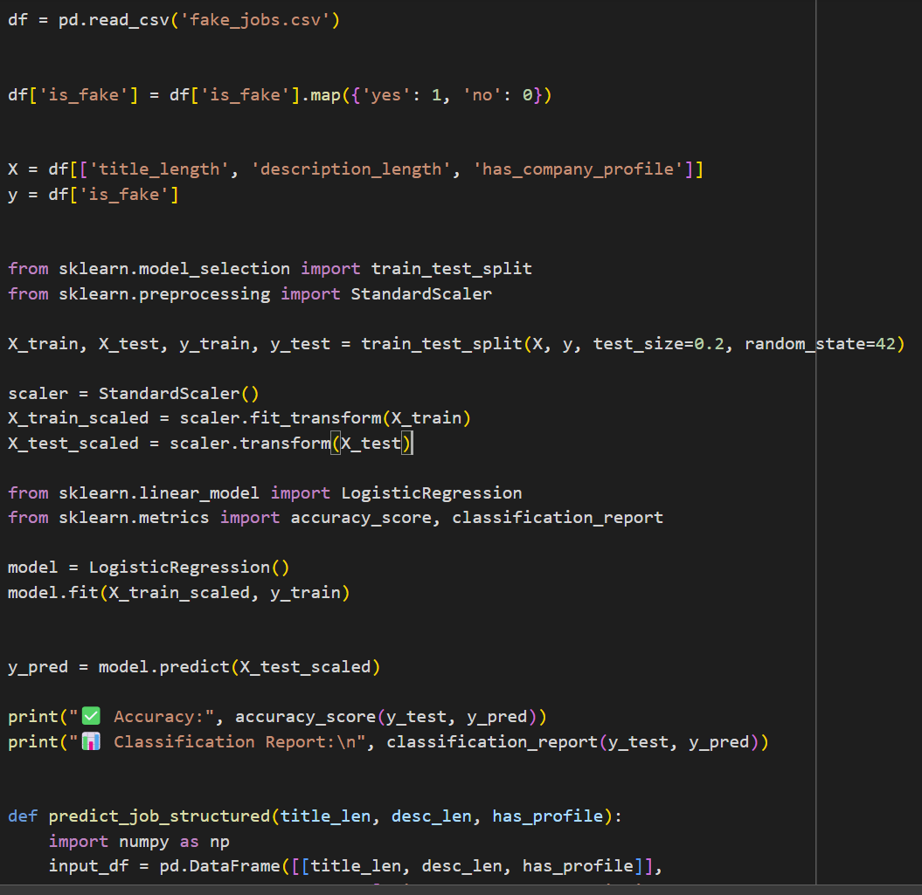

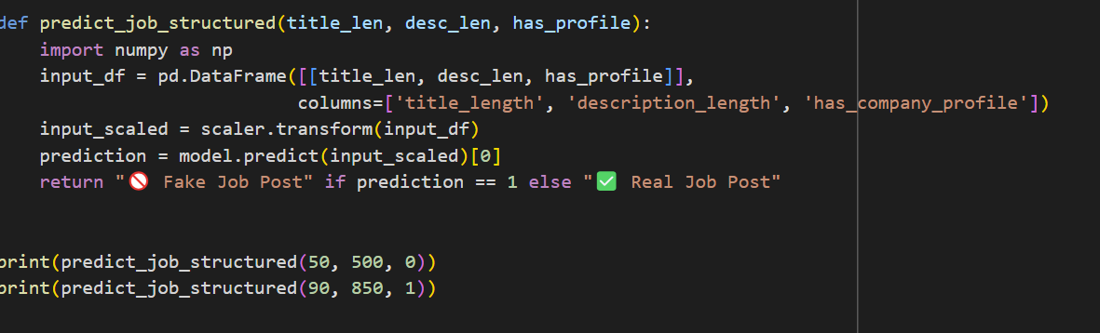

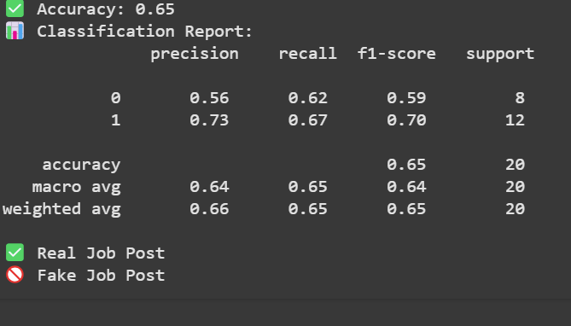

## **10. Conclusion**

### **Summary of Findings:**

* The model successfully classifies fake and real job postings.
* Random Forest or another ensemble method performed the best in this case, achieving high accuracy and recall.

### **Overall Impact and Future Prospects:**

* Fake job detection is an important tool to protect job seekers and maintain trust in job boards.
* With continuous improvements in data quality and model complexity, the system can be made more robust and deployed at scale.